**Notepad:**

Notepad is **basic** **text** **editor**. Here we create txt files. It is built-in application from windows. Notepad file extension .txt

Opening notepad:

Search > notepad

**Examples**:

product guides:

terms and condition:

serial number: 44asd-7845a-8787as-4454as

save: ctrl+S

**Wordpad:**

wordpad is used to create **basic** **documents** such as letter, reports, etc.. Here we create rtf files. It is built-in application from windows. Wordpad file extension .rtf

**Examples**:

applicaiton

date:18-12-2024

from

save: ctrl+s

**MS office:**

Microsoft office is an office automation software **suite** which consists of different applications that meet the day-to-day information needs of a business.

**Applications in MS Office 2021:**

* **MS** **Word**: used to **create** **documents** such as letters, reports, booklets, etc
* **MS** **Excel**: used to **create** **workbooks**, perform table data in worksheets, perform calculations on data, charts, data analysis, vlookup, pivot table, etc
* **MS** **Power**P**oint**: used to **create** **presentation** slides for projects, seminar, etc

**Versions of MS Office:**

MS Office 2007, 2010, 2013, 2016, 2019, **2021** (file > account)

**Office 365** – It is a Microsoft Product. It is a paid service. It is upgrading every day.

**Google** **office**: It is a google product, works in cloud only. Google office contains applications such as google docs, google sheets, google slides. It is free service.

**Android** **app**: WPS office - writer, spreadsheets and presentation. It is paid service.

**Word 2021**

**Route: click on search > word**

**Definition of Word:** MS Word is a full-featured word processor that can be used to create letters, reports, booklets, notices, brochures, etc.

**Parts of MS-Word 2021**

**Quick Access Toolbar**

**RibbonTabs**

**Ribbon**

**Dialog Box Launcher**

**File** **name**

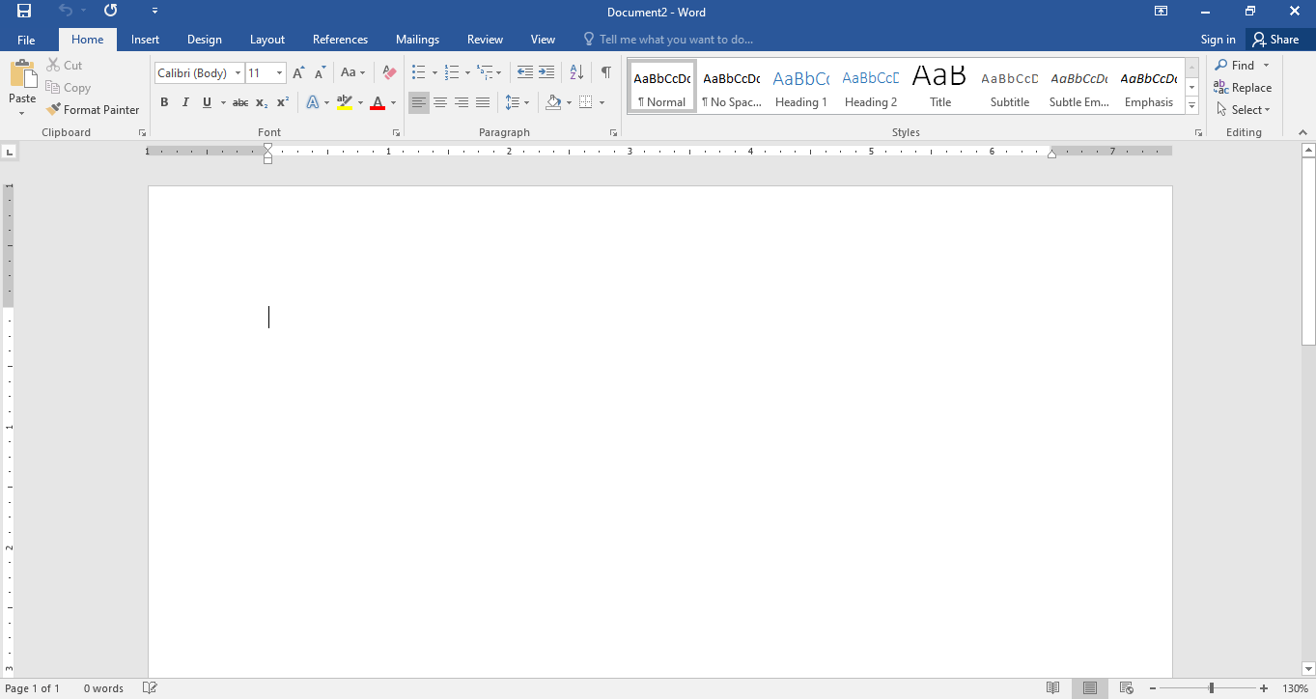

**Horizontal** **ruler**

**commands**

**Insertion** **point   
(blinking vertical line)**

**Groups**

**Scroll** **bar**

**Horizontal** **ruler**

**Page info.**

**Status Bar**

**View buttons**

**Zoom Slider 100%**

**Quick access toolbar(QAT):** the QAT is a customizable toolbar that contains frequently used commands.

**Live preview:** which temporarily applies formatting on the selected text or object when you move the mouse over of the formatting button.

**Mini** **toolbar**: the mini toolbar popup whenever text is selected. This new feature provides easy access to the most commonly used formatting commands in word.

**Word** **wrap**: a word processing feature in which cursor automatically goes to next line without pressing enter key. Therefore, do no press enter at the end of every line unless you require a paragraph break.

To start a new paragraph, press enter.

To start a new line without considering it as a new paragraph, press shift+enter

Creating a table: level 1

Route: insert >table >select columns and rows

**ZP High School**

**Madanapalle**

**Class**: 10th Class **Year**: 2020-21

|  |  |  |  |  |  |  |
| --- | --- | --- | --- | --- | --- | --- |
| **S.No** | **Name** | **Telugu** | **English** | **maths** | **total** | **Average** |
| 1. | G.Kiran kumar | 85 | 64 | 92 |  |  |
| 2. | S.Charan | 85 | 68 | 42 |  |  |
| 3. | P.Pavan kumar | 95 | 74 | 65 |  |  |

**Components of table:**

* Columns
* Rows
* Cell
* Record
* Resize table
* Select table data and move table

**Insert** **Columns**: right click on cell > insert > insert column to right

**Insert** **Rows**: right click on cell > insert > insert rows below

**Delete** **Column**: right click on cell>delete cell>delete entire column

**Delete** **Row**: right click on cell>delete cell>delete entire row

**Delete** **table**: select table by using selecting button > right click >delete table

**Formula**: to perform simple calculations such as SUM, Average, count, etc

Route: click on the cell >layout>formula

**Sort**: arrange the table data in alphabetical order or numerical order.

Route: click on the cell >layout>sort

**Table style:** Design >table style

**Covert** **to** **text**: convert the table to regular text.

Route: select table>layout> convert to text

Split table: ctrl+shift+enter

# Creating a table: level 2

**ZP High School**

**Madanapalle**

**Class**: 10th Class **Year**: 2020-21

|  |  |  |  |  |  |  |
| --- | --- | --- | --- | --- | --- | --- |
| **S.No** | **Name** | **Subjects** | | | **total** | **Average** |
| **Telugu** | **Physical science** | **Social studies** |
| 1. | G.Kiran kumar | 85 | 64 | 92 |  |  |
| 2. | S.Charan | 85 | 68 | 42 |  |  |
| 3. | P.Pavan kumar | 95 | 74 | 65 |  |  |

**Merge** **cells**: merge the selected cells into one cell.

Route: select cells to be merged, right click>merge cells

**Alignment**: to position the cell contents

Route: select cells > layout>alignment group> click center button

**Text** **direction**: change the text direction within the selected cells.

Route: select cells > layout>alignment group> Text direction

**Window+h**: speech to text